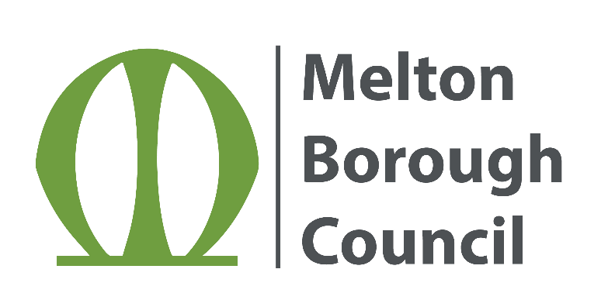
Subject Access Request
of data held by
Melton Borough Council

Part 1 – The Request

I am the person the information is about
If yes, please tick and then complete Parts 3, 4, 5 and 6
OR
I am acting on behalf of someone else
If yes, please tick and then complete Parts 2, 3, 4, 5 and 6

Part 2 – The information I am requesting
Personal Representative
I am the personal representative for the deceased person
I have enclosed evidence to support the above statement

Third Party
I am requesting the information on behalf of someone else
I enclose a consent to share form signed by the individual; OR
I enclose a DPA exemption on letterheaded paper appropriately signed
If you are making the request on behalf of someone else, please give YOUR details below.

Item | Details
Full Name
Relationship to the Data Subject
Address
Tel Number
Email address

Part 3 – Data Subject - Person that the information relates to
Item | Details
Title
Surname
First name
Maiden, previous or other names
Date of birth
Current Address
Postcode
Tel Number
Email address

3.1 Identification Documents - please select one from each section
Proof of Address | Photographic Proof of Identification
Bank Statement | Passport
Utility Bill | Driving Licence
Other (Please state): | Other (Please state):

Part 4 – Details of the information that you want access to.
Please help us deal with your request quickly and efficiently by giving as much detail as possible about the information the request is in relation to and the service(s) you have received, for instance, Housing or Planning etc.

Part 5 – Access to the Information

All information is provided in hard copy, unless specified otherwise.
If you have any special needs when viewing information, please state here:

Part 6 – Declaration

I certify the information provided on this form is true. I understand Melton Borough Council is not obliged to comply with my request unless they are supplied with such information as they may reasonably require in order to satisfy themselves as to my identity and to locate the information which I seek.

Name:

Signature:

Date:

Warning:

A person who unlawfully obtains, or attempts to obtain, personal information is guilty of a criminal offence and is liable to prosecution.

Send this completed form to: Data Protection
Melton Borough Council
Parkside
Station Approach
Melton Mowbray
LE13 1GH
info@melton.gov.uk

Data Protection – The information included on this form will be used for the purpose of handling your subject access request and will not be kept longer than is necessary to do so.

