Melton Borough Council
Statement of Accounts 2020-21 Subject to Audit
Declaration Under Part 5, Regulation 15 of the Local Government, England & Wales , The Accounts and Audit Regulations 2015

I declare that the Statement of Accounts 2020-21 Subject to Audit is unaudited and that the Statement of Accounts 2020-21 Subject to Audit as published may be subject to change.

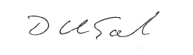

Dawn Garton
Section 151 Officer
Melton Borough Council

30 July 2021

