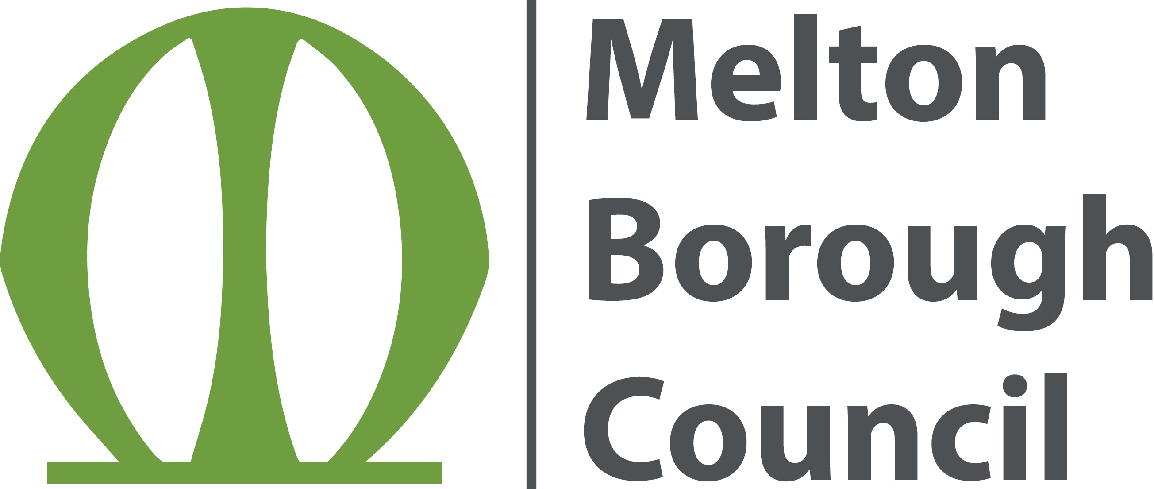

Licensing Act 2003

REPRESENTATION FORM

Your name/organisation name/name of
body you represent
Postal and email address
Contact telephone number

Name of the premises you are making a
representation about
Address of the premises you are making a representation about.

Your representation must relate to one of the four Licensing Objectives (see note 2)
Licensing Objective | Yes Or  No | Please detail the evidence supporting your representation or the reason for your representation.  Please use separate sheets if necessary
To prevent crime and disorder
Public safety
To prevent public nuisance
To protect children from harm

Please suggest any conditions that could be added to the licence to remedy your representation or other suggestions you would like the
Licensing Sub Committee to take into account (see note 2).

Signed: Date:
Please see notes on reverse

NOTES

- This form must be returned within the statutory period of 28 days from the date the application was displayed on the premises of the date given in the public notice in a local newspaper or other local publication.

- These can only relate to the four licensing objectives.

- If you do make a representation you will be invited to attend a meeting of the Licensing Sub-Committee and any subsequent appeal proceeding. If you do not attend, the Committee will consider any representations that you have made.

- Your representation will be passed to the applicant, to allow them the opportunity of addressing your concerns. Your representations will be published in the report available to the Licensing Sub-Committee, which will be publicly available. Names and addresses will only be withheld from the Sub-Committee report at your request. Email addresses and contact telephone numbers will not be publicly available.

- Please return this form when completed to: The Licensing Officer
Melton Borough Council Parkside
Station Approach Melton Mowbray LE13 1GH

Tel: 01664 502502
Email: licensing@melton.gov.uk

