We are seeking your views on housing in the Melton Borough to help us develop a housing strategy We have published a draft strategy Draft housing strategy to help set out what we think the main issues and objectives might be and we would like your views on it.

1. About you...
Please select the statement that best describes you...
☐Member of the public
☐Parish Councillor or Neighbourhood plan group member
☐ Community group or charity representative
☐Private rented sector landlord or agent
☐ Affordable or Social housing provider
☐Housing support, care or other service provider
☐ Development, construction or planning professional
☐Other (please specify)

If you are responding on behalf of an organisation please state its name

Questions 2 and 3 only apply to people who are responding as a representative of a housing related organisation.
If this does not apply to you please move onto question 4 on the next page.
If you are responding on behalf of a group, sector or organisation we would like to better understand your housing related issues and priorities and how the council might be able to work with you to help address them.

2. What are your organisations key housing related issues and priorities below?

3. Is there anything the council or others might be able to do to help you address them?

You are welcome to attach your organisations plans or polices to your response to help us understand your organisations key issues and priorities.
We would like to undertake some more in-depth conversations with people and organisations who are involved in delivering housing or housing related services in the Melton Borough If you would be willing to participate in a short telephone or video call, please could you provide your contact details below.
Name:
Organisation:
Email:
Telephone:

4. What do you think are the most important housing issues in the Melton borough?
The draft housing strategy sets out some key local housing facts and issues. We would like to know your views on them and any other housing issues you think we need to consider Set out below are a number of issues highlighted in the draft housing strategy.
Please tick a box to rate each on a scale where 1 is not very important and 5 is very important to you.
 | Not Very Important |  |  |  | Very Important
 | 1 | 2 | 3 | 4 | 5
Homelessness | ☐ | ☐ | ☐ | ☐ | ☐
Affordability of housing | ☐ | ☐ | ☐ | ☐ | ☐
Supporting home ownership and first time buyers | ☐ | ☐ | ☐ | ☐ | ☐
Sufficient good quality rented housing | ☐ | ☐ | ☐ | ☐ | ☐
Older people and the aging population | ☐ | ☐ | ☐ | ☐ | ☐
Sufficient accessible and adaptable housing | ☐ | ☐ | ☐ | ☐ | ☐
Support to help people live independently in their own homes | ☐ | ☐ | ☐ | ☐ | ☐
More housing to meet the needs of the growing population | ☐ | ☐ | ☐ | ☐ | ☐
Infrastructure to support new housing development (e.g. road improvements, school places and GP capacity) | ☐ | ☐ | ☐ | ☐ | ☐
Protecting historic buildings and local character | ☐ | ☐ | ☐ | ☐ | ☐
Quality of existing homes | ☐ | ☐ | ☐ | ☐ | ☐
Design of new homes | ☐ | ☐ | ☐ | ☐ | ☐
 | Not Very Important |  |  |  | Very Important
 | 1 | 2 | 3 | 4 | 5
The climate emergency | ☐ | ☐ | ☐ | ☐ | ☐
Fuel poverty | ☐ | ☐ | ☐ | ☐ | ☐
Impacts from coronavirus pandemic | ☐ | ☐ | ☐ | ☐ | ☐
Other (please specify) | ☐ | ☐ | ☐ | ☐ | ☐

5. Please share any comments on what you think are the most important housing issues are locally and why.

The proposed objectives
We would like your views on the four objectives set out in the draft housing strategy, shown below...
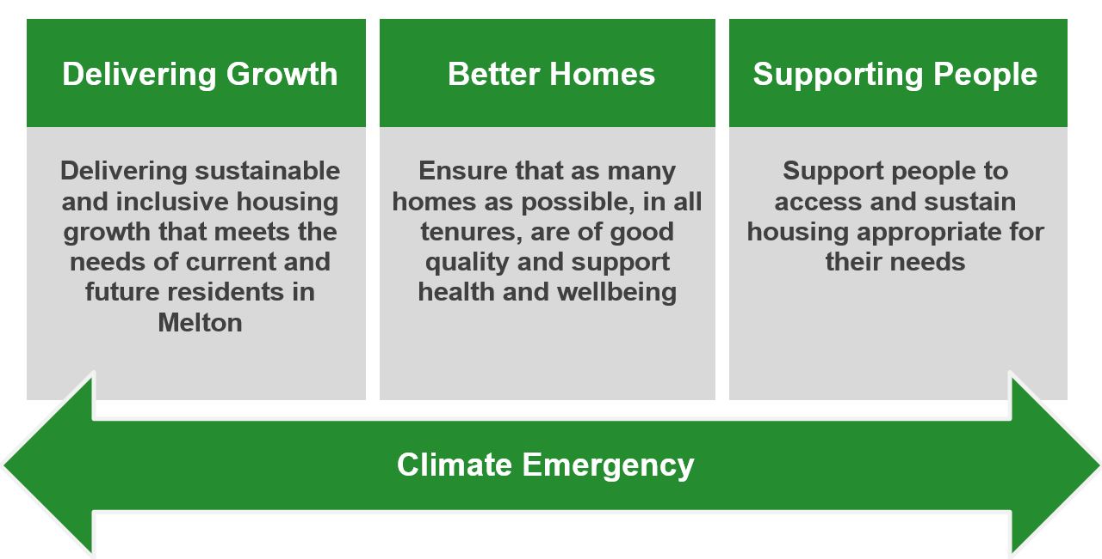

6. Do you think we have set out the right objectives?
☐ Yes ☐ No ☐ Don’t know ☐Other (please specify below)

7. Please indicate how much you agree or disagree with each objective
Please tick a box to rate how much you agree with each objective
Delivering Growth Objective | Completely Disagree | Disagree somewhat | Neutral | Agree Somewhat | Completely Agree
Delivering sustainable and inclusive housing growth that meets the needs of current and future residents in Melton | ☐ | ☐ | ☐ | ☐ | ☐
Any comments on this objective?

Better Homes Objective | Completely Disagree | Disagree somewhat | Neutral | Agree Somewhat | Completely Agree
Ensure that as many homes as possible, in all tenures, are of good quality and support good health and wellbeing | ☐ | ☐ | ☐ | ☐ | ☐
Any comments on this objective?

Supporting people Objective | Completely Disagree | Disagree somewhat | Neutral | Agree Somewhat | Completely Agree
Support people to access and sustain housing appropriate for their needs | ☐ | ☐ | ☐ | ☐ | ☐
Any comments on this objective?

Climate Emergency Objective | Completely Disagree | Disagree somewhat | Neutral | Agree Somewhat | Completely Agree
Ensure climate change implications are considered at all stages of planning, delivery and occupations of homes | ☐ | ☐ | ☐ | ☐ | ☐
Any comments on this objective?
Would you like to suggest any alternative objectives?

Do you have any other comments on the objectives set out in the draft housing strategy?

8. What do we need to do?
We would also like your views on what you think needs to be done to address local housing issues. The actions you would most like to see the Council and others take and why.
What do you think the Council needs to do?

Who else needs do you think needs to take action and what do they need to do?

9. Equalities
To make sure that equality considerations have been considered from the outset we have undertaken an Equalities Impact Statement to help inform the development of the draft housing strategy. We are publishing this alongside the draft housing strategy and welcome feedback on it as part of the consultation.
Do you have any comments on equalities or the equalities impact statement?

10. Last question...
Do you have any other comments?
Please add in any other comments you may have on housing or the draft strategy here...

11. Optional equality and diversity monitoring form

Melton Borough Council is committed to providing high quality services fairly and without discrimination to all members of the community. The following information will help us in our aim to continually improve the quality of our services for everyone and to identify if any particular areas of the community which are found to be under represented. Please note;
- Completion of this questionnaire is entirely voluntary and you may choose to complete all, none or part of this questionnaire.
- Only submit/return this form/questionnaire if you consent to the Council processing your information for equality monitoring purposes.
- All questionnaires are anonymous and any information you provide will remain confidential.
Q1 Post Code:
(Please provide the first 5 digits e.g.LE13 1)

Q2 At birth were you described as....
(please tick the box which best describes you):
☐ Male
☐ Female
☐ Intersex
☐ I prefer not to say
Q3 Which of the following describes how you think of yourself?
(please tick the box which best describes you):
☐ Male
☐ Female
☐ In another way
☐ I prefer not to say

Q4 My Sexual orientation is...
(please tick one box only)
☐ Heterosexual/Straight
☐ Bisexual
☐ Other
☐ Gay Man
☐ Gay Woman/Lesbian
☐ Prefer not to say
Q5 Which of the following age groups do you belong to?
(please tick one box only)
☐ Under 16
☐ 16 to 18
☐ 19 to 24
☐ 25 to 34
☐ 35 to 44
☐ 45 to 54
☐ 55 to 64
☐ 65 to 74
☐ 75 & over
☐ Prefer not to say
Q6 Do you consider yourself to have a health problem or a disability which has lasted, or is expected to last at least 12 months?
☐ Yes
☐ No
If YES - please state the nature of your disability or illness
(please tick all appropriate boxes)
☐ Physical impairment (e.g. using a wheelchair to get around and/or difficulty in using your arms)
☐ Sensory impairment (e.g. being blind or deaf)
☐ Mental health conditions (e.g. depression, schizophrenia)
☐ Learning disability (e.g. dyslexia, Downs syndrome)
☐ Cognitive impairment (e.g. autism, head injury)
☐ Long-standing illness or health condition (e.g. cancer, HIV, diabetes, chronic heart disease)
☐ Other (please specify)…
Q7 My racial origin is....
(please tick the box that best/most closely describes your ethnic origin)
Asian: ☐ Indian ☐ Pakistani
☐ Bangladeshi ☐ Chinese
☐ Other
Black: ☐ British Caribbean ☐ British African
☐ Other
Mixed/Duel: ☐ White/Black Caribbean ☐ White/Black African
☐ White/Asian ☐ Other
White: ☐ British ☐ Irish
☐ Other
Q8 My Religion/ Belief is....
(please tick the box which best describes you):
☐ Buddhist ☐ Christian ☐ Hindu
☐ Jewish ☐ Muslim ☐ Sikh
☐ Other ☐ No religion
Thank you for taking the time to complete this form

