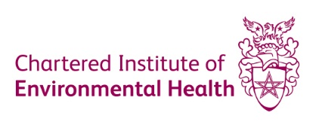 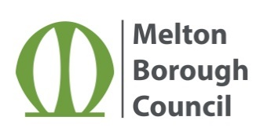

# Semi permanent make up - microblading treatments. Are you at risk?

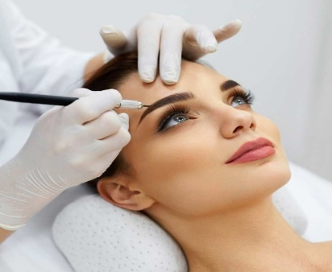

# What is microblading?

Microblading is a form of tattooing; it is carried out using a blade, which is made up of a row of fine needles. The blade is dipped into a coloured pigment (ink) and then placed into the upper layer of the skin with a slicing motion to create fine hair like strokes. The results are natural looking fuller eyebrows.

# What are the risks?

The microblading procedure involves puncturing the skin and inserting a pigment (ink). If the microblading equipment is re-used between clients, it will become contaminated and can result in causing localised infection at the site of the puncture or the transmission of blood-borne viruses, for example, Hepatitis B, Hepatitis C or HIV. Allergic reactions to the pigment, numbing cream and ointments used as well as scarring from repeated procedures are also associated risks of microblading.

 Common symptoms of infection to look out for:

* Fever
* Swelling
* Tenderness
* Discharge – yellow/green/brown colour
* Off-putting smells

If you experience any of the above symptoms, please seek medical advice and report your concerns to your Local Environmental Health Department.

Melton Borough Council, Parkside, Station Approach, Burton Street, Melton Mowbray, Leicestershire, LE13 1GH